Project Planning Phase
Project Planning Template (Product Backlog, Sprint Planning, Stories, Story points)

Date | 01 June 2026
Team ID | SWTID-2026-7507
Project Name | Darshan Ease
Maximum Marks | 5 Marks

Product Backlog, Sprint Schedule, and Estimation (4 Marks)
Use the below template to create product backlog and sprint schedule
Sprint | Functional Requirement (Epic) | User Story Number | User Story / Task | Story Points | Priority | Team Members
Sprint-1 | Registration | USN-1 | As a devotee, I can register on Darshan Ease using my email, mobile number, and password, confirming my password. | 5 | High
Sprint-1 |  | USN-2 | As a devotee, I receive a confirmation email/SMS after successfully registering on the app. | 3 | High
Sprint-1 |  | USN-3 | As a devotee, I can register and log in using my Google account. | 3 | Medium
Sprint-1 | Login | USN-4 | As a devotee, I can log in using my registered mobile number and OTP. | 5 | High
Sprint-1 |  | USN-5 | As a devotee, I can reset my forgotten password via my registered email. | 4 | Medium
Sprint-2 | Temple Discovery | USN-6 | As a devotee, I can search for temples by name or location. | 4 | High
Sprint-2 |  | USN-7 | As a devotee, I can view available darshan slots and timings for a selected temple. | 4 | High
Sprint-2 | Slot Booking | USN-8 | As a devotee, I can book a darshan slot for my chosen date and time. | 6 | High
Sprint-2 |  | USN-9 | As a devotee, I can select the number of pilgrims included in my booking. | 3 | Medium
Sprint-2 |  | USN-10 | As a devotee, I can view my past and upcoming booking history. | 3 | Low
Sprint-3 | Payment | USN-11 | As a devotee, I can pay my darshan booking fee online via UPI, card, or net banking. | 6 | High
Sprint-3 |  | USN-12 | As a devotee, I receive a QR-code e-ticket after successful payment. | 4 | High
Sprint-3 |  | USN-13 | As a devotee, I can cancel a booking and request a refund. | 4 | Medium
Sprint-3 | Queue Management | USN-14 | As temple staff, I can scan a devotee's QR ticket to validate entry at the gate. | 3 | High
Sprint-3 |  | USN-15 | As a devotee, I can view my live queue position and token number. | 3 | Medium
Sprint-4 | Notifications | USN-16 | As a devotee, I receive SMS/push notification reminders before my darshan slot. | 3 | High
Sprint-4 | Admin Dashboard | USN-17 | As a temple admin, I can add and edit temple details, slot capacity, and timings. | 6 | High
Sprint-4 |  | USN-18 | As a temple admin, I can view booking analytics and daily footfall reports. | 5 | Medium
Sprint-4 | Reviews & Feedback | USN-19 | As a devotee, I can rate my darshan experience and leave feedback. | 3 | Low
Sprint-4 |  | USN-20 | As a devotee, I can view a crowd-level indicator for a temple before booking. | 3 | Medium

Project Tracker, Velocity & Burndown Chart: (4 Marks)
Sprint | Total Story Points | Duration | Sprint Start Date | Sprint End Date (Planned) | Story Points Completed (as on Planned End Date) | Sprint Release Date (Actual)
Sprint-1 | 20 | 6 Days | 01 Jun 2026 | 06 Jun 2026 | 20 | 06 Jun 2026
Sprint-2 | 20 | 6 Days | 08 Jun 2026 | 13 Jun 2026 | 20 | 13 Jun 2026
Sprint-3 | 20 | 6 Days | 15 Jun 2026 | 20 Jun 2026
Sprint-4 | 20 | 6 Days | 22 Jun 2026 | 27 Jun 2026

Velocity:
For Darshan Ease, the team follows a 6-day sprint duration, and the team's velocity is 20 story points per sprint. Let’s calculate the team’s average velocity (AV) per iteration unit (story points per day):
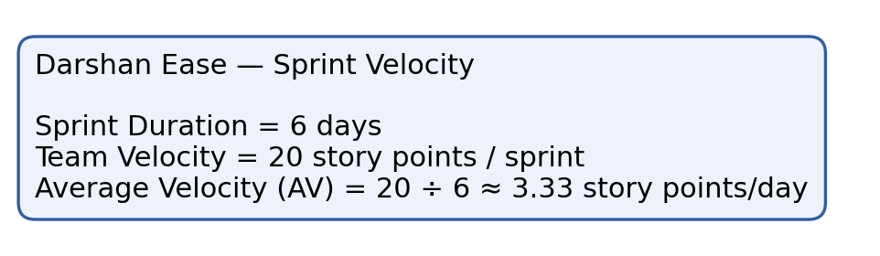

Burndown Chart:
A burn down chart is a graphical representation of work left to do versus time. It is often used in agile software development methodologies such as Scrum. However, burn down charts can be applied to any project containing measurable progress over time.
Below is the Sprint-1 burndown chart for Darshan Ease, tracking story points remaining over the sprint:
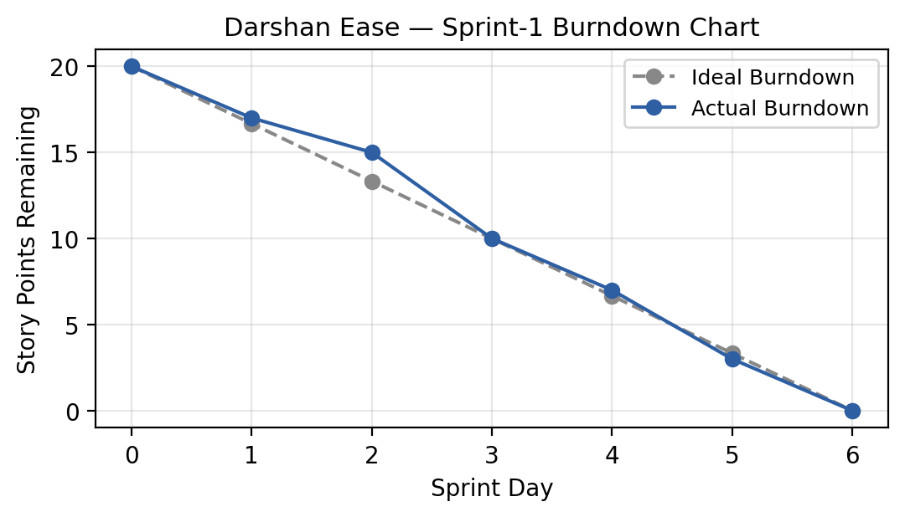

https://www.visual-paradigm.com/scrum/scrum-burndown-chart/
https://www.atlassian.com/agile/tutorials/burndown-charts

Reference:
https://www.atlassian.com/agile/project-management
https://www.atlassian.com/agile/tutorials/how-to-do-scrum-with-jira-software
https://www.atlassian.com/agile/tutorials/epics
https://www.atlassian.com/agile/tutorials/sprints
https://www.atlassian.com/agile/project-management/estimation
https://www.atlassian.com/agile/tutorials/burndown-charts

